a) to list the contents of a directory, we need to have read(r) permission

b) to enter a directory - execute(x) permission

c) to create and delete files inside a directory - write(w) permission We are able to modify these access rights by "chmod" command. For ex.:

chmod u=rwx,g=rwx,o=rwx \*.txt

where u, g, o stand for user, group, other respectively (i.e., in that case we gave access to read, write and execute a file for each of these groups).

The biggest file inside /usr:

/usr/lib/firefox/libxul.so

I executed this in such a way: 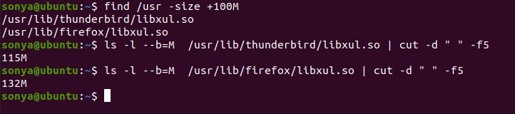

sonya@ubuntu:~$ find /usr -size +100M

/usr/lib/thunderbird/libxul.so

/usr/lib/firefox/libxul.so

sonya@ubuntu:~$ ls -l --b=M /usr/lib/thunderbird/libxul.so | cut -d " " -f5

115M

sonya@ubuntu:~$ ls -l --b=M /usr/lib/firefox/libxul.so | cut -d " " -f5

132M